Caring for the Kaw
My Personal Action Plan

This notebook was created for the lessons on
https://sites.google.com/site/teens4thekaw/caring-for-the-kaw

Your Name | Date
Your Town | Your County
Your Watershed

Unit 1-What’s Your Water Footprint Part 1

Record the number of gallons per person per year calculated by the Water Footprint Calculator*:

Multiply this by 4 to get the amount for a 4-person household:

If the average American 4-person household uses 130,000 gallons of water, do you use more or less than this average? How much more or less?

*http://goblue.zerofootprint.net/one_minute/unilever/countries/56105
Unit 1-What’s Your Water Footprint Part 2
How much water do you use to brush your teeth and wash your face?

Number of seconds water runs:

Now run the water for the same amount of time and count the number of cups filled:

Multiply this by the number of times per day your wash your face and brush your teeth:

(cups/day) x (1 gallon/16 cups) x (365 days/year) = gallons/year =

Unit 1-What’s Your Water Footprint Part 4
Record your measurements | Calculate total gallons used per year
How many loads of laundry do you do per week? Divide this by the number of people in your family. | (loads/week) x (25 gallons/load) x (48 weeks/year) = gallons/year
How many times do you wash dishes each day? Divide this by the number of people in your family. | (loads/day) x (20 gallons/load) x (365 days/year) = gallons/year

How many times do you flush the toilet each day? | (flushes/day) x (3 gallons/flush) x (365 days/year) = gallons/year =
How many minutes do you shower each day? | (minutes/day) x (2 gallons/minute) x (365 days/year) = gallons/year =
How much water do you use to wash your face and brush your teeth? | You measured this in Part 2:

Your Annual Water Budget

Add up all of these values:
Gallons used to wash face and brush teeth:
Gallons used to wash clothes:
Gallons used to wash dishes:
Gallons used to shower:
Gallons used to flush toilet:

Annual Total:

Unit 2-How Much Stormwater Runs Off Your House? Part 1

Take a tape measure and measure how long your house is and how wide it is. Draw a sketch of your house on the next page and write your measurements on the sketch.

What is the total area of your house? If you multiply the length (measured in feet) by the width (measured in feet) you will get the area in feet²

Use the calculations on the website to determine how much water will run off of your house during a 1 inch rainstorm.

https://sites.google.com/site/teens4thekaw/caring-for-the-kaw/stormwater

Unit 2-How Much Stormwater Runs Off Your House? Part 2
Look around your yard for things that might pollute the water that runs off your house. Record your observations in the table below.

Pollution source | How can you reduce it?

Unit 3-Know Your Watershed
Where does your water come from?
Where does your sewage go to?

Where does your electricity come from?

What watershed do you live in?

Are there any bridges over the Kansas River that you have driven over?

Unit 4- Map Your Connection to the Kaw

How far is your school from the Kansas River?

What is the most interesting thing you saw on the Google Earth map?

What is the weirdest thing you saw?

Unit 5- Your Personal Action Plan Part 1

The picture on the next page is a logo created for Friends of the Kaw by Temashio Anderson and Nasbah Ben. Color it in and look at all the things in it? Can you see how these things might affect the river?

This is an example of a logo that tells a story—it shows us what stormwater runoff is all about. Try to make your own logo that shows us what you learned about how you are connected to the Kaw. You can use the blank pages after our logo to draw your own logo for your Action Plan.

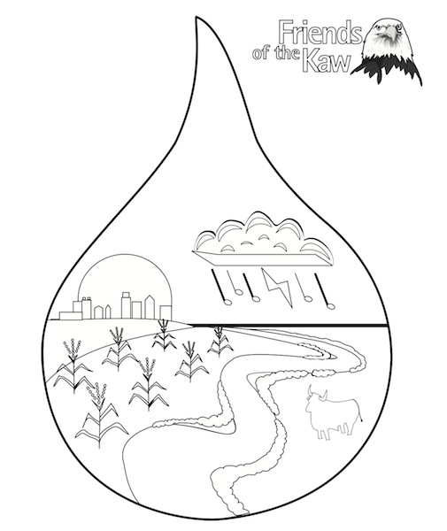

Unit 5- Your Personal Action Plan Part 2
Use the blank pages at the end to write out an Action Plan.

- What do you do around the house that uses the most water? Can you think of a way to reduce the amount of water you use?

- Is there anything you do around the house that causes pollution, like dumping chemicals down the drain? What can you do to help?

- Can you think of any way to reduce the amount of stormwater that runs off your house and yard?

- Did you find any sources of pollution in your yard that could wash off during a rainstorm and pollute the river? Can you do anything to reduce the problem?

- What did you find out about the river near your community? Is there something that might be really good about the river (like lots of sandbars, lots of trees along the banks) or are there things that might be a problem (lots of industries that might pollute the water, all the trees have been cut down).

- What can you tell others about why the Kansas River is important to all of us?

