Annual Dinner and Silent Auction
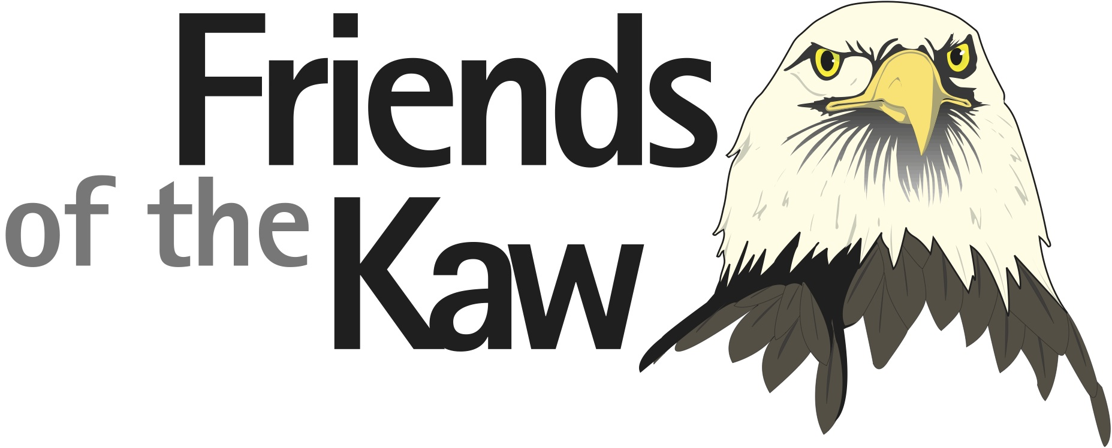
Wednesday, November 5, 2014
6pm to 9pm at the
Bass Pro Shop in Olathe, KS (just SW of I-35 and 119th Street)

Speaker: Tracy Streeter, Director of the Kansas Water Office
Topic: 50-Year Vision for the Future of Water in Kansas
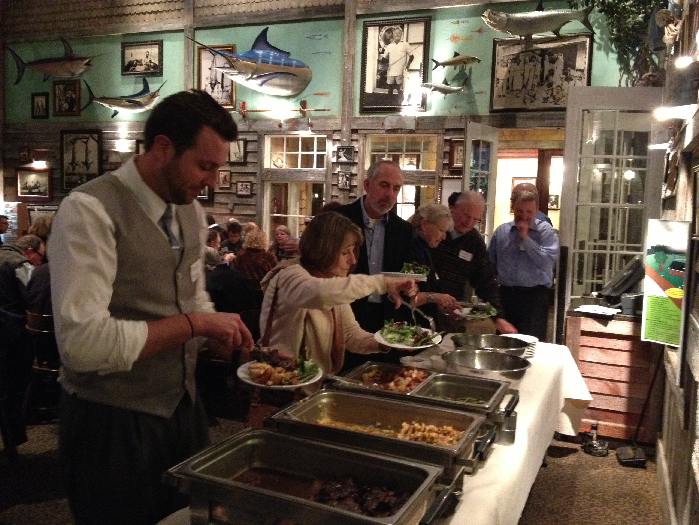
Enjoy a delicious buffet dinner:
- Garden Salad
- Grilled Chicken w/ Pineapple Salsa
- Beef Sirloin w/ Red Wine Sauce
- Green Beans & Wild Rice
- Dessert & Beverage

Cost: $45 - RSVP with check or credit card by Oct. 29
Enjoy a cash bar, informative speaker, and the opportunity to bid on fabulous silent auction items.
All proceeds benefit Friends of the Kaw.
____________________________________________________________________________
Name(s): _______________________________________________________
Address: _______________________________________________________
City: ______________________________ State: _____ Zip: ___________
Email: _____________________________________ Phone: ___________
______ x $45 = _______
Credit Card (circle one) Visa Mastercard
Number: ___________________________ Expiration Date: ___ / ___
Mail to: Friends of the Kaw
c/o Laura Calwell
5610 W. 61st Terrace
Mission, KS 66202
OR
Call: 785-312-7200

